Overnight Berry Oats
YIELD 1 SERVINGS  Ingredients  1/2 cup quick oatmeal  1/2 cup almond milk  1 tsp chia seeds  2 tbsp sliced almonds  1 cup mixed berries  Nutritionals Per Serving  □ Calories 180 Cal  □ Protein 10 grams  □ Fiber 12 grams  □ Sugar 29 grams  □ Carbs 59 grams  □ Fat 10 grams | PREP 5 MIN | COOK 0 MIN | TOTAL overnight  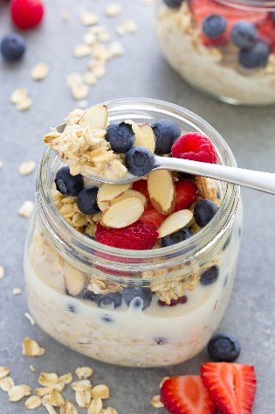  Directions  Step 1  Add your oats to a glass jar and poor in your nondairy milk. Make sure to stir well so all the oats are coated with the milk.  Step 2  Mix in your chia seeds and stir well to integrate.  Step 3  Top your oats with sliced almonds and fresh, frozen or freeze-dried berries of choice. Seal the container with a lid and place in the refrigerator overnight.  Step 4  Grab your oats in the morning and enjoy.  Tips  Use your preferred nondairy milk. We are blessed to have so many choices these days oat, almond, hemp, soy and coconut milks to name a few. Add your favorite berries or use up what berries you might have on hand.

