Wild Mushroom Legume Pasta
YIELD 2 SERVINGS  Ingredients  8 oz uncooked orecchiette or rotini legume pasta  2 tbsp olive oil  2 garlic cloves chopped  ½ cup sweet onion diced  12 oz cremini mushroom sliced  1/3 cup dry white wine  ¼ tsp dried thyme  ¼ tsp dried oregano  ½ cup mushroom broth  2 tbsp vegan butter  3 tbsp flour  Salt and pepper to taste  Nutritional’s Per Serving  □ Calories 325 Cal  □ Protein 10 grams  □ Fiber 5 grams  □ Sugar 3 grams  □ Fat 6 grams  □ Carbs 38 grams | PREP 8 MIN | COOK 12 MIN | TOTAL 20 MIN  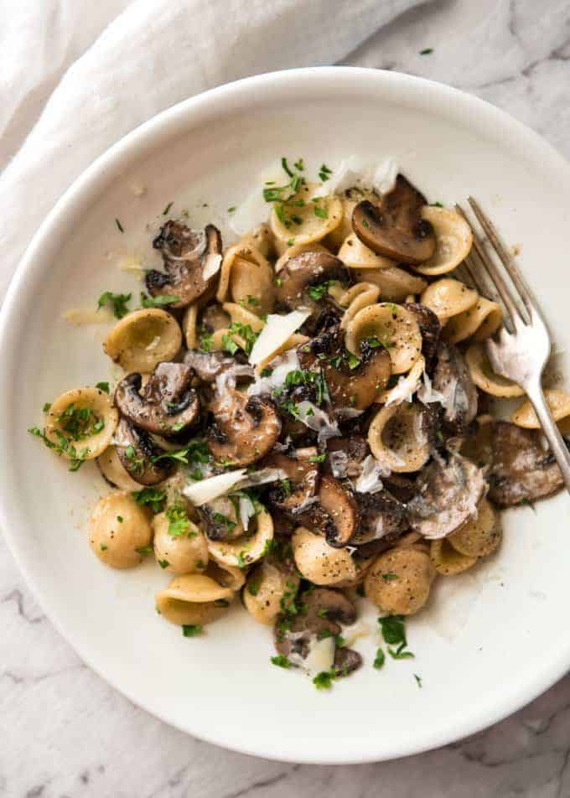  Preparations  Bring a medium sized saucepan filled with the recommended water from your preferred pasta and a pinch of salt to a boil. Cook your pasta per the recommended instructions leaving it al dente or shorten the cooking time by 1-2 minutes. Once finished drain and rinse with cold water and set aside.  While your pasta is cooking chop your fresh mushrooms, onion and the fresh garlic.  Heat a larger sized saucepan over medium high heat and add the olive oil. Once the oil is heated lay the sliced mushrooms out in the pan. Do not crowd your mushrooms, make sure there is space between them and cook on both sides until they are golden brown 3-5 minutes. Using tongs is best. If you overcrowd your mushroom’s they will release their liquid and they will not brown.  Once the mushrooms are cooked add the onion to the pan and cook 2-3 minutes, then add the garlic and cook another minute. Once the vegetables are cooked add the butter and flour to create a roux which is a technique used to thicken and create a sauce. Mix well so there is no lumps about 1 minute. If the roux is to thick add a little more butter.  Pour your wine in the pan while stirring all ingredients and cook until the wine is almost evaporated from the pan. Once the wine has reduced add the mushroom broth, toss in the herbs and pasta and cook until the broth thickens a bit for 2-3 minutes. Add a pinch of salt and pepper to taste and your pasta dish is ready to eat!  Tips  You can use vegetable broth instead of mushroom broth. The wine gives the dish a depth of flavor and brings it to the next level but it's important to use a dry wine, do not add a sweet wine to this dish!  ​If you want the sauce to thicken more just add another tablespoon of flour in a small amount of cold broth or water whisk so no lumps appear and add to the sauce. This will thicken it up more to your desired consistency. If the sauce is too thick add a little more broth.  ​You can use any preferred pasta you like but the key is to cook it al dente so you can finish cooking it in the pan with the vegetables. If you over cook the pasta it will start falling apart.

Notes

