Breakfast
YIELD 6 SERVINGS  Ingredients  1 cup rolled oats  1 cup oat bran  3 ripened bananas  2 tbsp peanut butter  1 tbsp chia seeds  ½ cup coconut shredded  2 tsp vanilla extract  ½ cup chopped walnuts  3 diced dried figs  ½ cup dried cranberries  Nutritionals Per Serving  □ Calories 360 Cal  □ Protein 10 grams  □ Fiber 10 grams  □ Sugar 20 grams  □ Carbs 52 grams  □ Fat 14 grams | Cranberry Oat Muffins  PREP 10 MIN | COOK 20 MIN | TOTAL 30 MIN  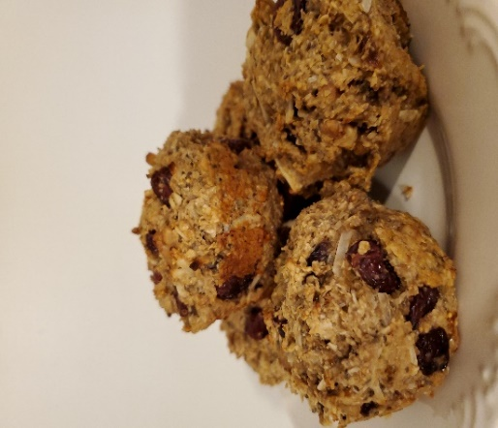  Directions  Heat oven to 375 degrees.  Dry Mix  Mix the oatmeal, oat bran, chia seeds, walnuts, cranberries and shredded coconut in a medium sized mixing bowl. Dice the figs into small cubes and add to the dry mixture.  Banana Mash  Peel the bananas and mash in a bowl with a fork. Add the peanut butter and vanilla extract to the banana mixture, blend with a spatula until smooth.  Muffin Madness  Fold in the dry mix with the banana mash, mix well until all ingredients are incorporated. Place equal portions of the muffin mix into a non-stick muffin pan. Place in oven at 375 and bake for 20 minutes or until golden brown.  Tips  Use ripe bananas for this recipe, they will blend into the mixture better. Add more oats if the mixture is too runny and add more mashed bananas if the mixture is too dry.

NOTES

