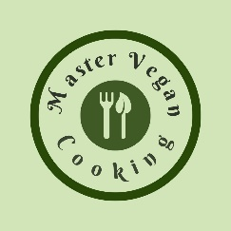

Sweet Potato Quinoa Tacos
YIELD 2 SERVINGS  Ingredients  6 corn tortilla wraps  ½ cup quinoa cooked  1 cup vegetable broth  1 medium sized sweet potato cooked, peeled & diced  1 tbsp Mexican spice  1 jalapeno pepper diced  ½ cup diced red onion  1 cup shredded red cabbage  ½ cup avocado dressing  1 lime sliced in wedges  Salt to taste  Nutritional’s Per Serving  □ Calories 437 Cal  □ Protein 14 grams  □ Fiber 10 grams  □ Sugar 5 grams  □ Carbs 66 grams  □ Fat 12 grams | PREP 15 MIN | COOK 23 MIN | TOTAL 38 MIN  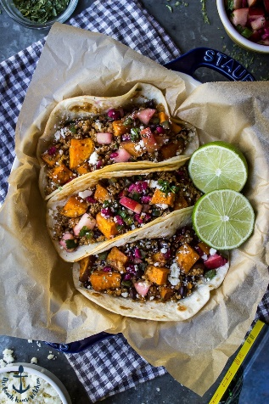  Preparations  Bring the vegetable broth to a boil in a small saucepan. Add the rinsed quinoa once the broth is boiling, stir and place a lid on the pan and reduce the heat to a low simmer. Cook the quinoa for 15 minutes. Once the quinoa is fully cooked set aside in a prep bowl.  While the quinoa is cooking, wash the sweet potato and pat dry. Poke holes in the potato using a fork or knife four or five times. There is no need to wrap your potato but place it on a plate and cook in a microwave on full power for 5 minutes. Cook a few minutes longer if you cannot easily place a fork in the center of the potato. Once the potato is cooked set aside to cool. Cut the potato into small ½ inch cubes and add to the quinoa bowl.  Dice up a small jalapeno and add the pepper and Mexican spice (see recipe) in the quinoa mix and stir well. Add salt and pepper to taste. Finely chop the red onion and cut the red cabbage in julienne strips and set aside.  Make the avocado dressing (see recipe).  Turn the Broil on your stove and spread the sweet potato mixture on a non-stick sheet pan. Place the pan on the top rack in the oven and cook for four minutes, then flip the mixture over and cook for another four minutes until you see a golden-brown crust.  Plate the tacos placing the corn tortillas on a plate, fill the tortillas with shredded cabbage sweet potato mix and top with avocado dressing. Garnish with lime.  Tips  Use sprouted corn tortilla wraps if you can find them. They have more antioxidants and nutrients than the typical corn wraps. If you do not like spice or heat do not use the jalapeno pepper and just use the Mexican spice blend. Use more vegetable broth if the quinoa starts sticking to the pan while cooking. If you like a crunchy texture use the broil feature in your stove to crisp the mixture this allows for a crisp texture without using oil. You can certainly serve the mixture without broiling it. Cook the quinoa over the weekend and pull out to use when you are ready to make the tacos. This will save you cooking time during the week if you are rushed for time. Top with your favorite salsa or sauce! Garnish with Avocado and lime.

Notes

