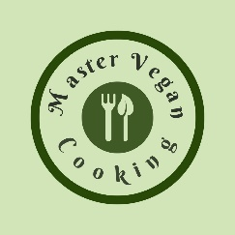
YIELD 1 SERVINGS  Ingredients  2 medium beets  1 medium cucumber  2 large carrots  1 medium bunch of Lacinato Kale  1 bunch of parsley  1 small lemon  1 tsp Matcha powdered green tea  1 tsp Moon Juice anti-aging minerals  1 scoop unflavored plant protein powder  Nutritional’s Per Serving  □ Calories 135 Cal  □ Protein 24 grams  □ Fiber 3 grams  □ Sugar 0 grams  □ Carbs 4 grams  □ Fat 2.5 grams | Morning Beet Blast  PREP 10 MIN | TOTAL 10 MIN  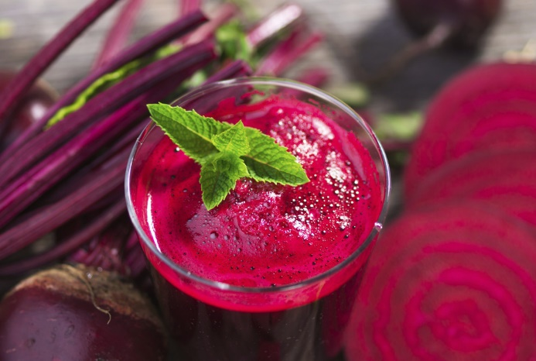  Preparations  Make sure you clean and wash your vegetables before you make your juice. This is especially important because you will be consuming this juice in its natural raw state, the way nature intended!  Once your vegetables are cleaned make sure they are cut if needed to fit in your juicer. (Depends on the juicer you have)  It does not matter what order you juice your vegetables although I tend to juice one vegetable at a time then move onto the next.  Once you finish juicing all your yummy vegetables add your powder ingredients and blend till silky smooth. Drink it right away or store it in the refrigerator up to 24 hours depending on your juicer.  Tips  The key to making any juice especially for your workouts is to be prepared to make them quickly. That means have your fruits and vegetables washed and ready to grab and extract your juice when you are ready! I always wash my produce then place them in food containers in the refrigerator so I can quickly get them when I need them!  ​Having your produce and ingredients organized and ready will help you quickly prepare your workout drink when needed!

