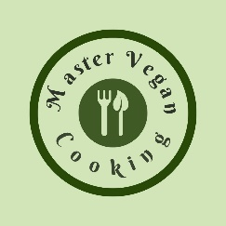

Raspberry Bomb
YIELD 1 SERVINGS  Ingredients  1 cup raspberries  1/2 cup blueberries  1/2 cup acerola cherries  6 oz cashew milk  1 tsp agave nectar  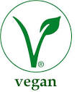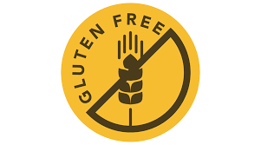  Nutritional’s Per Serving  □ Calories 170 Cal  □ Protein 4 grams  □ Fiber 11 grams  □ Sugar 24 grams  □ Carbs 34 grams  □ Fat 2 grams | PREP 15 MIN | TOTAL 15 MIN  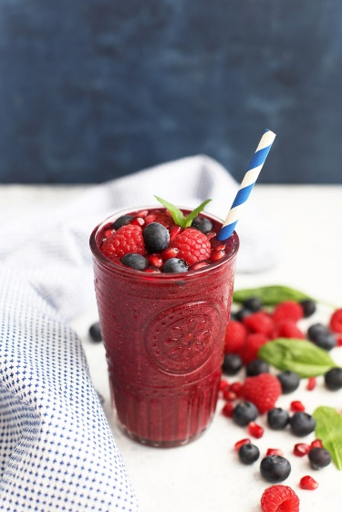  Preparations  Make sure you clean and wash your fruit before you make your smoothie. This is especially important because you will be consuming this drink in it's natural raw state, the way nature intended and no one wants to get sick!  Once your fruit is cleaned you can add your cashew milk, berries and agave into the blender and mix until silky smooth.  If you want the smoothie to be thinner poor in more cashew milk. If you want the smoothie to be thicker add more berries  Once you finished blending the smoothie poor into a mason jar. Garnish with fresh mint and enjoy your delicious smoothie!  Tips  Purchase frozen berries to save some money. Best to buy in a club like Costco to save the most money.  You can make your own nut milk if you want to save some money or buy it bulk in a club.

