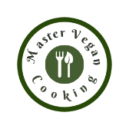 Soup
YIELD 6 SERVINGS  Ingredients  1 medium butternut squash  1 apple  3 garlic gloves  1 small sweet onion  1 can 15.5 oz great northern white beans  4 cups vegetable broth  1 tbsp raw pumpkin seeds  1 tsp nutmeg  1 tsp turmeric  Salt to taste  Pepper to taste  1tbsp olive oil  Nutritionals Per Serving  □ Calories 144 Cal  □ Protein 6 grams  □ Fiber 7 grams  □ Sugar 6 grams  □ Carbs 30 grams  □ Fat .1 grams | Roasted Squash Bean Soup  PREP 10 MIN | COOK 45 MIN | TOTAL 55 MIN  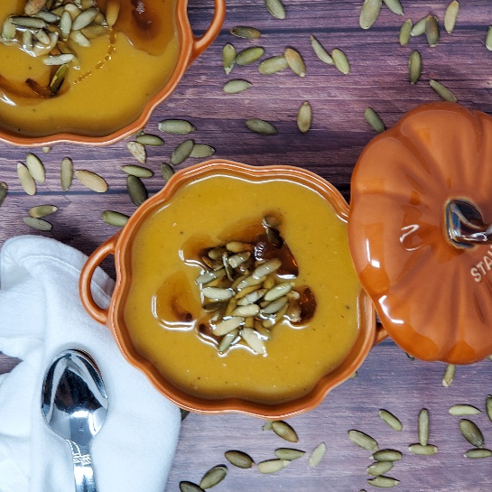  Directions  Step 1  Preheat the oven to 400 degrees. Clean, peel and cut the squash up into large chunks and place on a non-stick baking sheet.  Step 2  Cut the apple into quarters and discard the seeds. Slice the onion into quarters. Place the apple and onion onto the baking sheet. Discard the skin of the garlic gloves and add to the baking sheet and drizzle a little olive oil onto the pan to avoid sticking. Place the pan in the oven and bake for 45 minutes or until a fork can easily pierce the squash.  Step 3  While you are waiting for the vegetables to roast. Rinse and drain the beans and toss them into a blender. Add ½ up of vegetable broth to the beans, cover and blend until smooth. Pour the mixture into a medium-large Dutch oven pot or soup pot. Once the vegetables are roasted blend them in small batches while adding some vegetable broth until you get your desired texture. Once each batch of vegetables is blended smooth you can pour the mixture into your soup pot or Dutch oven.  Step 4  Place your soup pot on the cook top and turn the heat onto medium-low. Add your seasonings, turmeric, nutmeg, salt and pepper to taste. Stir until warm and serve in bowls. Garnish with raw pumpkin seeds.  Tips  To roast the squash evenly it’s best to cut it into large chunks. If you need to change the consistency of the soup just add more vegetable broth to thin it down. Sometimes I add a little cinnamon and cumin to the soup which can add more depth of flavor. While you can cook the vegetables and make this soup in an Insta-Pot, I highly recommend the roasting method as it gives such a great roasted flavor to your soup.  NOTES

