Roasted Cider Glazed Squash
YIELD 4 SERVINGS  Ingredients  1 butternut squash  1 oz avocado oil  ¼ tsp pumpkin spice  ¼ cup turbinado sugar  2 tbsp apple cider vinegar  ½ cup pecans chopped  2 tsp fresh rosemary chopped  2 tbsp dukkah spice  Salt and pepper to taste  Nutritional’s Per Serving  □ Calories 260 Cal  □ Protein 4 grams  □ Fiber 4 grams  □ Sugar 12 grams  □ Fat 14 grams  □ Carbs 37 grams | PREP 12 MIN | COOK 33 MIN | TOTAL 45 MIN  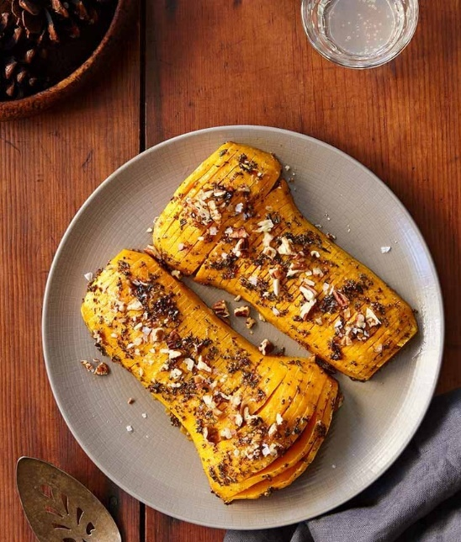  Preparations  Preheat the oven to 425 degrees F. Wash your squash then use a peeler to remove the skin, peeling until you see deep orange flesh. Cut the ends of the squash off, then proceed to slice the squash in halve and scooping out the seeds with a spoon. Rub the squash with avocado oil and place cut side down on a sheet pan. Sprinkle with salt and pepper to taste. Roast until slightly tender, 15-20 minutes depending on the size. The squash is cooked if you can insert a knife or fork in the thickest part easily.  Make the glaze by adding the turbinado sugar, apple cider vinegar and a pinch of salt to a small saucepan over medium heat, and whisk until the glaze thickens 3-5 minutes. Remove from heat and set aside to cool.  To make the rosemary pecan dukkah spice blend roughly chop the pecans. Pick the rosemary leaves, discard the stems, and finely chop. Add the chopped pecans and rosemary, the dukkah spice and pumpkin spice to a medium bowl and combine the ingredients.  Remove the roasted butternut squash from the oven and place wooden spoons on both sides of the squash and slice cutting 3/4 of the way through the squash. Try not to cut all the way through so the squash stays intact. Spread a layer of glaze over the squash and sprinkle a layer of dukkah spice then roast for another 15-20 minutes in the oven.  Once the squash is fully cooked glaze the squash with the remaining cider vinegar and sprinkle the remaining dukkah spice blend over the top. Garnish with Rosemary. Serve on a platter!  Tips  To prep the butternut squash, use a peeler to remove the skin of the squash, peeling it until you see the pumpkin orange color. Slice each end off from the squash and then carefully cut in half lengthwise. Scoop out the seeds and string in the center. When roasting a butternut squash cooking time varies because the size of squash varies but you will know if it is cooked if a knife can easily puncture the flesh.

Notes

