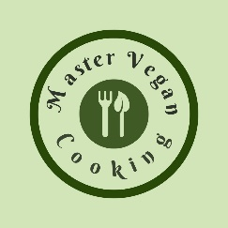

Health Nut
YIELD 1 SERVINGS  Ingredients  1 green apple  1/2 medium avocado  1 tbls peanut butter  5 oz cashew milk  1 scoop plant protein powder  1 tsp agave nectar  1/4 cup ice  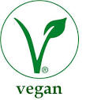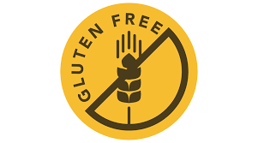  Nutritional’s Per Serving  □ Calories 428 Cal  □ Protein 14 grams  □ Fiber 7 grams  □ Sugar 15 grams  □ Carbs 33 grams  □ Fat 24 grams | PREP 15 MIN | TOTAL 15 MIN  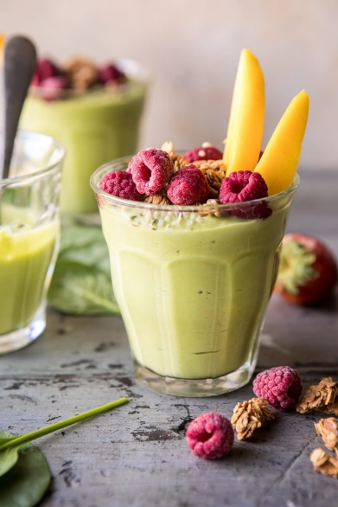  Preparations  Make sure you clean and wash your fruit before you make your smoothie. This is especially important because you will be consuming this drink in its natural raw state, the way nature intended, and no one wants to get sick!  Once your fruit is cleaned start prepping the avocado by cutting it in half and scooping out the pit with a spoon. Then you can take that same spoon and scoop out the flesh discarding the skin. Proceed to peel and core your apple.  Toss in your avocado, apple, peanut butter, cashew milk, plant protein and agave nectar into the blender and puree till smooth. Add in the ice and pulse to mix and get the ice chopped.  Once you finished blending the smoothie poor into a glass tumbler. Garnish with fresh sliced apples and enjoy your delicious smoothie!  Tips  Make your own fresh nut milk or purchase dry powdered nut milk if you want to save time. Use a dry peanut butter powder to add to your smoothies this makes the blending easier. Add the ice at the very end to give the smoothie a cool fresh taste!

