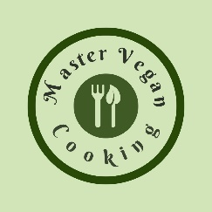

Fall Sweet Potato
YIELD 2 SERVINGS  Ingredients  2 medium sweet potatoes  ¾ cup basmati rice  ¼ cup dried cranberries  ¼ cup diced sweet onion  1 oz fresh chopped sage  2 garlic cloves chopped  ½ oz roasted pine nuts  1 oz olive oil  1 ¼ cup vegetable broth  Salt and pepper to taste  Nutritional’s Per Serving  □ Calories 470 Cal  □ Protein 5 grams  □ Fiber 4 grams  □ Sugar 18 grams  □ Fat 3 grams  □ Carbs 56 grams | PREP 15 MIN | COOK 15 MIN | TOTAL 30 MIN  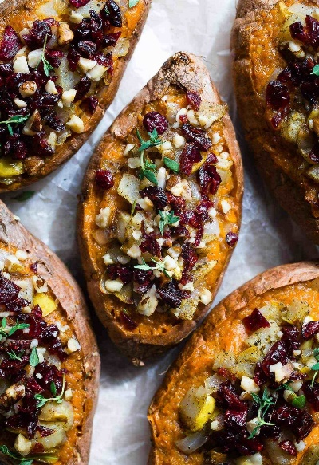  Preparations  Dice your onion, garlic cloves and fresh sage and toss in a medium size saucepan over medium heat and cook in the olive oil. Stir and cook for 1-2 minutes.  Add your pine nuts to the pan of ingredients and cook until lightly brown for another 2 minutes or so.  Poor your vegetable broth or water in the pot and add your basmati rice along with your cranberries. Cover and bring to a quick boil then reduce the heat to a simmer and cook for 13-15 minutes.  While your rice is cooking. Wash your potatoes and pat dry. Place your potatoes in an Instant Pot or Microwave and cook for about five minutes for a medium size potato. Try not to overcook you do not want a mushy potato!  Once the rice is fully cooked add some sea salt and ground pepper to taste. Stir and mix the ingredients well. Take your sweet potato and cut down the middle, scoring the potato in cubes but leaving the skin intact. Stuff your potatoes with the rice mixture. Top with extra sage or parsley and serve hot!  Tips  The easiest and quickest way to prepare this dish is to use an Instant Pot or microwave. You can cook a medium sized sweet potato in less than five minutes using one of these tools! If you do not have one of these tools, then you can certainly use your oven cooking a potato at 375 degrees for 40-45 minutes. You will know if a potato is done if you can easily stick a fork in the middle and pull out. The dish is best with fresh herbs, cooking the rice in broth and roasting the pine nuts. However, if money is tight you can certainly skip these by using water to cook the rice and use dry herbs and skip the nuts all together. The dish will still taste fabulous!

Notes

