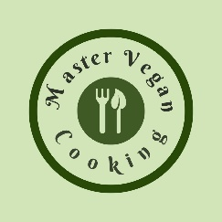
Grilled Tuscan Sandwich
YIELD 2 SERVINGS  Ingredients  2 ½ inch slices of extra firm tofu or 4 oz  ½ cup Italian dressing  2 tbsp of vegan pesto sauce  1 small tomato sliced  ¼ cup pickled red onion  ½ cup shredded kale  2 tbsp avocado oil  2 ciabatta bread sandwich rolls  Nutritional’s Per Serving  □ Calories 232 Cal  □ Protein 11 grams  □ Fiber 4 grams  □ Sugar 3 grams  □ Fat 9 grams  □ Carbs 25 grams | PREP 15 MIN | COOK 5 MIN | TOTAL 20 MIN  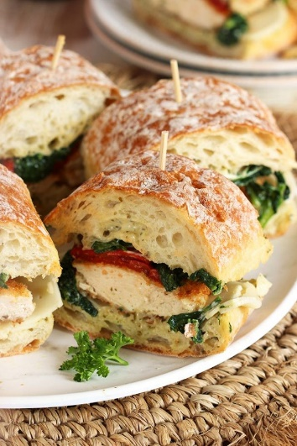  Preparations  Slice the extra firm tofu and place the pieces in a zip lock bag and pour the dressing over the top and gently massage so each piece is covered. Marinate for 10 minutes in the refrigerator.  Prepare your sandwich bread by slicing the roll if needed and toast the buns either over a grill or grill pan on the stove top.  Slice the fresh tomatoes and thinly cut the kale into shreds. Grab any other toppings you may want to put on your sandwich like pickled red onions (see recipe if you want to make your own)  Once the bread is grilled or toasted spread the pesto sauce on each bun and layer on the tomato slices, red pickled onion and shredded kale.  Take the tofu out of the marinade and cook on a medium grill or on a grill pan on the stove top over medium high heat. Sear the tofu on both sides 2-3 minutes. Once the tofu has nice grill marks and is warmed through it's ready to finish making the sandwich by placing it on the buns. Serve right away or wrap in brown waxed lined butcher paper and tie with twine!  Tips  This sandwich can also be served cold if you prefer. Just let the tofu cool down after grilling or place back in the refrigerator and pull out to assemble the sandwich when ready to eat.  To save time purchase the vegan pesto sauce, red pickled onions and Italian dressing. By doing this you can quickly make a sandwich in under 20- 15 minutes.

Notes

