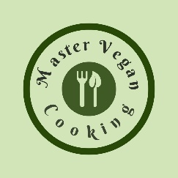

Vegetable Pho Noodle Bowl
YIELD 2 SERVINGS  Ingredients  6 cups Vegetable broth  1 cup chopped firm tofu  2 cups rice noodles  1 green onion diced  1 cup chopped carrots  1 cup cauliflower florets  1 cup broccoli florets  1 cup quartered mushrooms  1 sliced bok choy  Sriracha sauce to taste  Hoisin sauce to taste  1 tablespoon chopped cilantro  1 lime quartered  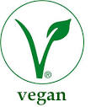  Nutritionals Per Serving  □ Calories 408 Cal  □ Protein 15 grams  □ Fiber 3 grams  □ Sugar 0 grams | PREP 10 MIN | COOK 10 MIN | TOTAL 20 MIN  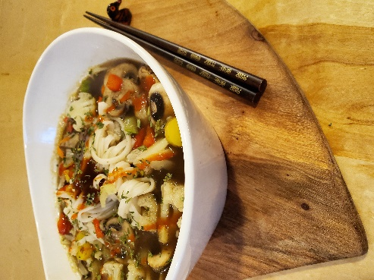  Preparations  Warm the vegetable broth up in a medium saucepan over Medium Hi heat.  Chop up the tofu, carrots, cauliflower, bok choy and broccoli into bite size pieces and add them into the vegetable broth. Dice the onion and quarter the mushrooms then add them into the broth. Cook the vegetables for 5-10 minutes depending on your preference for cooked vegetables.  In a separate sauce- pan bring the pot of water to a boil. Once the water is boiling add the rice noodles and cook until aldente about 6 minutes. Drain the noodles and add a serving of the noodles into an individual noodle or soup bowl.  Scoop the broth and vegetables into the noodle or soup bowl. Top with cilantro, fresh lime and season to taste with Sriracha and Hoisin sauce.  Tips  This is a fabulous dish to make for a quick & healthy dinner! You can use any vegetable you prefer so certainly swap your favorites in for this recipe. If you want extra flavor you can add vegan pho seasoning packets that can be found in most grocery stores. Alternatively, you can also use different broths like mushroom for a deeper richer flavor or try out vegetable bouillon of your choice.

