Pineapple Twist
YIELD 1 SERVINGS  Ingredients  1/2 fresh medium pineapple  1 mango peeled and pitted  1 medium cucumber  1 banana  1 small lemon  ½ cup coconut water  Nutritional’s Per Serving  □ Calories 240 Cal  □ Protein 3 grams  □ Fiber 3 grams  □ Sugar 46 grams  □ Carbs 49 grams  □ Fat 0 grams | PREP 10 MIN | TOTAL 10 MIN  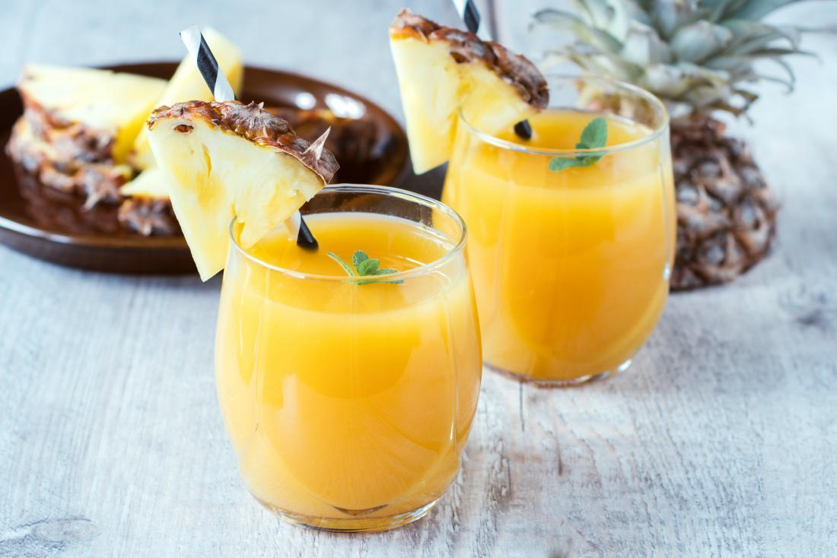  Preparations  Make sure you clean and wash your vegetables and fruit before you make your juice. This is especially important because you will be consuming this juice in its natural raw state, the way nature intended and no one wants to get sick!  Once your vegetables and fruit are cleaned make sure they are cut if needed to fit in your juicer. (Depends on the juicer you have)  Once you are done juicing the vegetables poor the juice and place all remaining ingredients to puree in a blender. Mix until very smooth.  Once you finish juicing and blending the drink poor into a glass and enjoy. Drink it right away or store it in the refrigerator up to 24 hours depending on your juicer.  Tips  The key to making any juice especially for your workouts is to be prepared to make them quickly. That means have your fruits and vegetables washed and ready to grab and extract your juice when you are ready! I always wash my produce then place them in food containers in the refrigerator so I can quickly get them when I need them!

