Pin

Pink Flamingo
YIELD 1 SERVINGS  Ingredients  1 cup chopped pitaya  1 cup strawberries  1 cup pineapple chunks  8 oz coconut water unsweetened  2 tbls agave nectar  Nutritional’s Per Serving  □ Calories 239 Cal  □ Protein 3 grams  □ Fiber 5 grams  □ Sugar 29 grams  □ Carbs 51 grams  □ Fat 0 grams | PREP 10 MIN | TOTAL 10 MIN  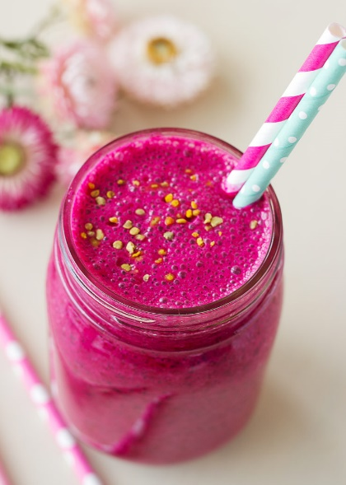  Preparations  Make sure you clean and wash your fruit before you make your juice. This is especially important because you will be consuming this juice in its natural raw state, the way nature intended, and no one wants to get sick!  Chop up your pineapple into chunks and take the tops off the strawberries. Slice the dragon fruit in half and scoop out the flesh with a spoon.  Poor the coconut water into the blender and add the fruit and blend until smooth with no chunks remaining. Add the agave nectar and blend for 10 seconds.  Poor your fruit juice into a glass add a festive straw. Enjoy your unique Asian inspired juice. It's bright pink and so delicious!  Tips  Wash your fruit really well to prevent any sickness. We suggest adding a couple tablespoons of white distilled vinegar to the water when cleaning your fruits and vegetables. Then set you produce out on a towel to dry off before storing. This will help prevent molding.  The easiest way to get the fruit out of the dragon fruit is to cut the fruit in half then scoop out the flesh.

