Dips/Spreads
YIELD 6 SERVINGS  Ingredients  3 ripe avocados, peeled & pitted  1 jalapeno cored & finely chopped  ¼ cup chopped cilantro  1 tbsp fresh lime juice  2 tbsp minced red onion  Sea salt to taste  Nutritional’s Per Serving ¼cup  □ Calories 91 Cal  □ Protein 2 grams  □ Fiber 3.8 grams  □ Sugar 0 grams  □ Carbs 5 grams  □ Fat 8.3 grams | Zesty Guacamole  PREP 10 MIN | COOK 0 MIN | TOTAL 10 MIN  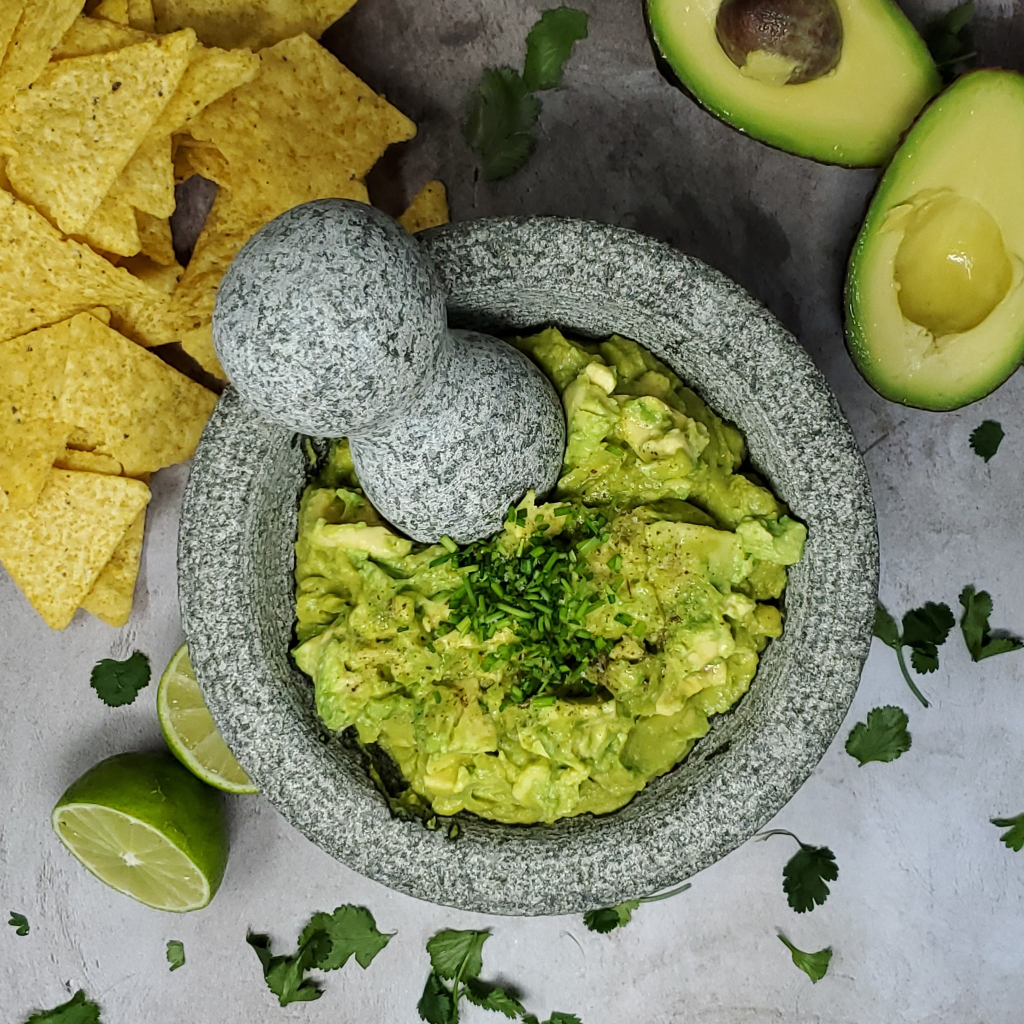  Preparations  Peel and pit the 3 avocados by cutting them in half. Remove the pit. Score the inside of the avocado with a blunt knife and scoop out the flesh with a spoon. Place the diced avocado in a medium mortar or bowl.  Mash with a pesto and mortar to preferred consistency.  Add the lime juice, sea salt, onion, cilantro and jalapeno, mix together and serve immediately. If intended to make ahead of time place plastic wrap over top. Refrigerate until ready to serve. Top off with fresh chopped cilantro and enjoy!  Tips  To keep the color of the bright green avocado, squeeze a little lime juice over top once the guacamole is completed then place plastic wrap over the top.  If you don’t like a little kick keep the jalapeno out to reduce heat.  Serving the guacamole in a mortar brings a sense of elegance and authenticity!

