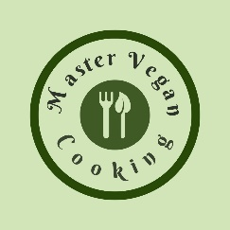

Berry Burst
YIELD 1 SERVINGS  Ingredients  1 cup strawberries  1 cup blueberries  1 cup raspberries  1 medium cucumber  2 medium carrots  4 oz coconut water  Nutritional’s Per Serving  □ Calories 197 Cal  □ Protein 4 grams  □ Fiber 17 grams  □ Sugar 18 grams  □ Carbs 40 grams  □ Fat 0 grams | PREP 10 MIN | TOTAL 10 MIN  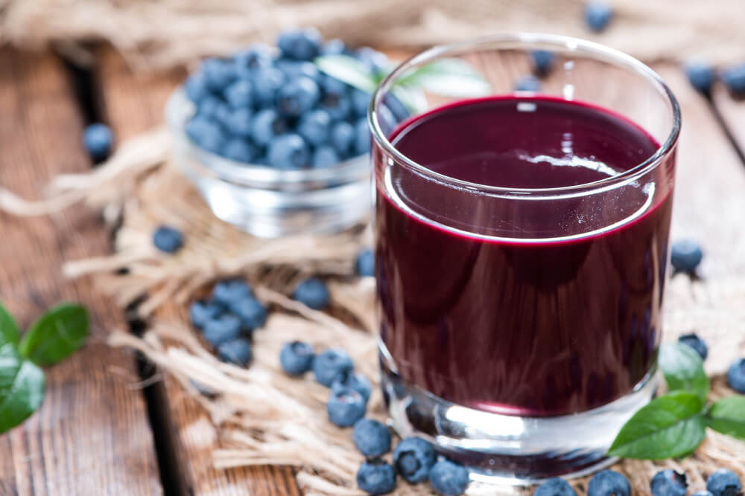  Preparations  Make sure you clean and wash your vegetables and fruit before you make your juice. This is especially important because you will be consuming this juice in its natural raw state, the way nature intended, and no one wants to get sick!  Add your cucumber then carrots to the juicer. Take the veggie juice and add it to a blender.  Once the veggie juice is added to the blender you can add all your berries and coconut water and blend till silky smooth.  Poor your berry juice into a glass and garnish with a sprig of fresh mint. Enjoy your berry burst freshly made juice. You might just get hooked on it!  Tips  Wash your fruit and vegetable really well to prevent any sickness. We suggest adding a couple tablespoons of white distilled vinegar to the water when cleaning your fruits and vegetables. Then set you produce out on a towel to dry off before storing. This will help prevent molding. If you don't like seeds you can strain the juice to get rid of the seeds. If you want more juice/liquid add more cucumber or coconut water.

