Greenie
YIELD 1 SERVINGS  Ingredients  2 bunches of kale  1 medium cucumber  2 large carrots  1 small lime  1/2 bunch of parsley  1 tsp Moon juice anti-aging minerals  1 tsp milk thistle  Nutritional’s Per Serving  □ Calories 112 Cal  □ Protein 9 grams  □ Fiber 4 grams  □ Sugar 0 grams  □ Carbs 10 grams  □ Fat 0 grams | PREP 10 MIN | TOTAL 10 MIN  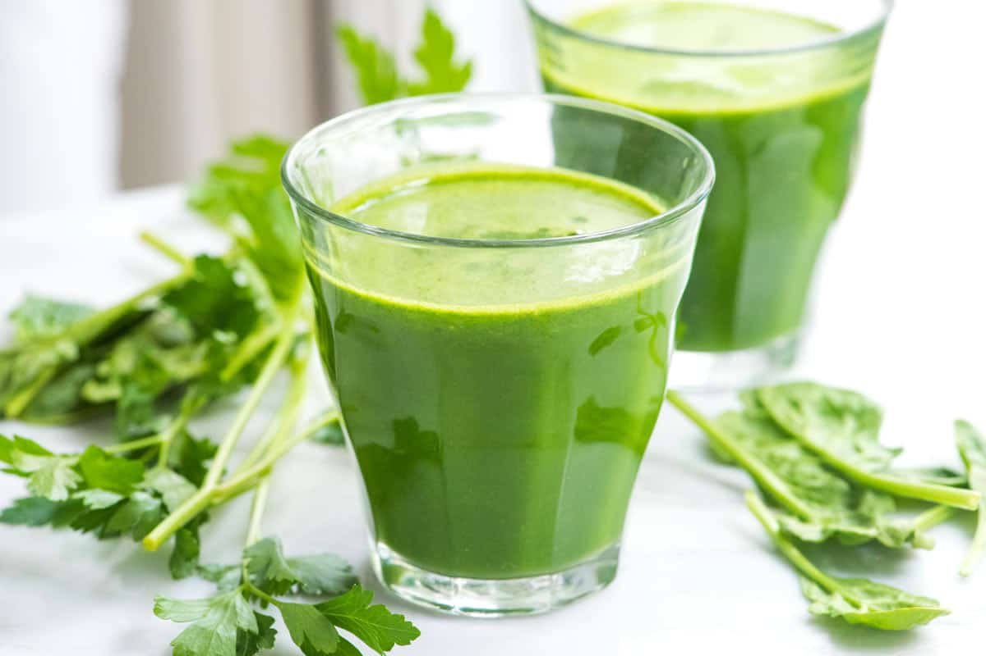  Preparations  Make sure you clean and wash your vegetables and fruit before you make your juice. This is especially important because you will be consuming this juice in its natural raw state, the way nature intended and no one wants to get sick!  Once your vegetables and fruit are cleaned make sure they are cut if needed to fit in your juicer. (Depends on the juicer you have)  It does not matter what order you juice your vegetables and fruit although I tend to juice one vegetable at a time then move onto the next.  Once you finish juicing all your yummy vegetables and fruit poor the juice into a blend bottle. Add your powder ingredients and mix till silky smooth. Drink it right away or store it in the refrigerator up to 24 hours depending on your juicer.  Tips  The key to making any juice is to be prepared to make them quickly. That means have your fruits and vegetables washed and ready to grab and extract your juice when you are ready! I always wash my produce then place them in food containers in the refrigerator so I can quickly get them when I need them!

